**ASSIGNMENT-1**

**By**

***Satyendra Sharma***

**Roll No. 2023A6R037**

**1ST SEMESTER**

**CSE (AI/ML)**



**Model Institute of Engineering & Technology (Autonomous)**

(Permanently Affiliated to the University of Jammu, Accredited by NAAC with “A” Grade)

Jammu, India

2023



1. ***Write a C program to print all three-digit Adam numbers.***

**#include <stdio.h>**

**#include <math.h>**

**int square(int n);**

**int squareroot(int n);**

**int reverse(int n);**

**void main()**

**{**

**int p,l,k,m;**

**for(int i = 100;i<=999;i++)**

**{**

**p = square(i);**

**m = reverse(p);**

**l = squareroot(m);**

**k = reverse(l);**

**if(i==k)**

**printf("%d ", i);**

**else**

**continue;**

**}**

**}**

**int square(int n)**

**{**

**int x;**

**x = n*n;**

**return x;**

**}**

**int squareroot(int n)**

**{**

**int x;**

**x = (int)sqrt(n);**

**return x;**

**}**

**int reverse(int n)**

**{**

**int rem=0,ans=0;**

**while(n){**

**rem = n%10;**

**ans = ans*10 + rem;**

**n/=10;**

**}**

**return ans;**

**}**

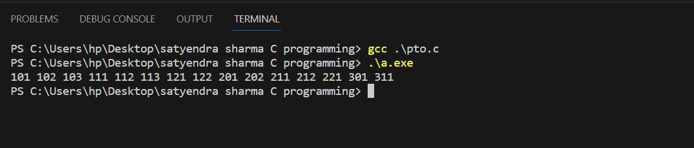

1. ***The following letters of the English alphabet are vowels: a, e, i, o, and u.***

***You are given a string named str of length n. Find and print the most frequent vowel in str.***

**#include <stdio.h>**

**#include <string.h>**

**void main()**

**{**

**int n,ca=0,ce=0,ci=0,co=0,cu=0;**

**printf("Enter the length of string :- ");**

**scanf("%d", &n);**

**char str[n];**

**printf("\nEnter the string :- ");**

**gets(str);**

**gets(str);**

**for(int i = 0; i < n; i++)**

**{**

**if(str[i] == 'a')**

**ca++;**

**else if(str[i] == 'e')**

**ce++;**

**else if(str[i] == 'i')**

**ci++;**

**else if(str[i] == 'o')**

**co++;**

**else if(str[i] == 'u')**

**cu++;**

**}**

**if(ca>ce&&ca>ci&&ca>co&&ca>cu)**

**printf("A");**

**else if(ce>ci && ce>co && ce>cu)**

**printf("E");**

**else if(ci>co&&ci>cu)**

**printf("I");**

**else if(co>cu)**

**printf("O");**

**else**

**printf("U");**

**}**